SEMESTER TWO
Papers written by Australian Maths Software

YEAR 11
MATHEMATICS SPECIALIST
Units 1 & 2
2016
REVISION 1
Section Two
(Calculator–assumed)

Name: __________________________________

Teacher: ________________________________

TIME ALLOWED FOR THIS SECTION

Reading time before commencing work: 10 minutes
Working time for section: 100 minutes

MATERIAL REQUIRED / RECOMMENDED FOR THIS SECTION

To be provided by the candidate
Standard items: pens, pencils, pencil sharpener, highlighter, eraser, ruler.

Special items: drawing instruments, templates, notes on up to two unfolded sheets of A4 paper, and up to three calculators approved for use in examinations.

IMPORTANT NOTE TO CANDIDATES
No other items may be taken into the examination room. It is your responsibility to ensure that you do not have any unauthorised notes or other items of a non–personal nature in the examination room. If you have any unauthorised material with you, hand it to the supervisor before reading any further.

To be provided by the supervisor
Question/answer booklet for Section Two.
Formula sheet retained from Section One.
Structure of this examination

 | Number of questions available | Number of questions to be answered | Working time (minutes) |  | Marks available | Percentage of exam
Section One  Calculator—free | 7 | 7 | 50 |  | 52 | 35
Section Two  Calculator—assumed | 12 | 12 | 100 |  | 98 | 65
Total marks |  |  |  | 150

Instructions to candidates

1. The rules for the conduct of this examination are detailed in the Information Handbook. Sitting this examination implies that you agree to abide by these rules.

2. Write your answer in the Question/Answer booklet.

3. You must be careful to confine your responses to the specific questions asked and to
follow any instructions that are specific to a particular question.

4. Spare pages are provided at the end of this booklet. If you need to use them, indicate in the original answer space where the answer is continued i.e. give the page number.

5. Show all your working clearly. Your working should be in sufficient detail to allow your answers to be checked readily and for marks to be awarded for reasoning. Incorrect answers given without supporting reasoning cannot be allocated any marks. For any question or part question worth more than two marks, valid working or justification is required to receive full marks. If you repeat an answer to any question, ensure that you cancel the answer you do not wish to have marked.

6. It is recommended that you do not use pencil, except in diagrams.

7. The Formula Sheet is not to be handed in with your Question/Answer booklet.

Section Two: Calculator–assumed 98 marks

This section has twelve (12) questions. Attempt all questions.
Working time: 100 minutes

Question 8 (5 marks)
(a) Solve for 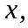 giving reasons. (2)
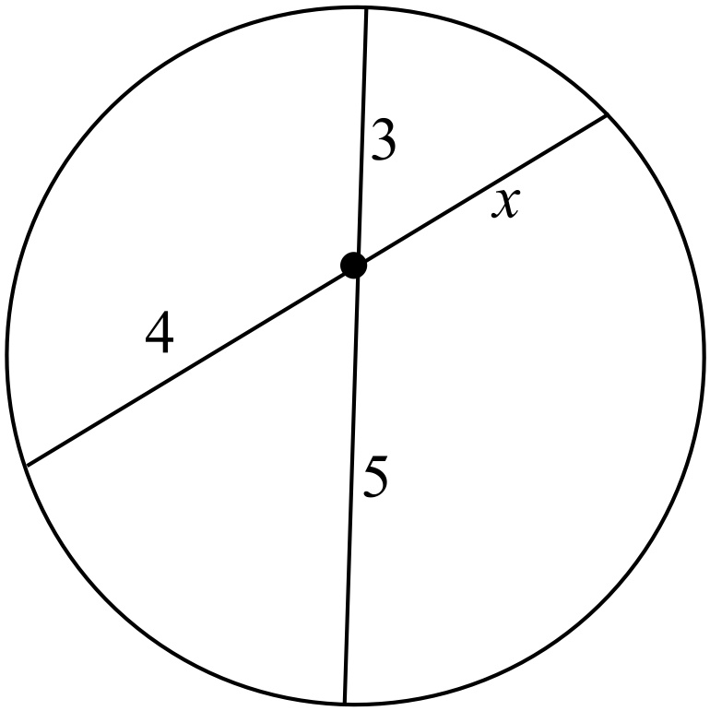

( b) Solve for and , giving reasons. (3)
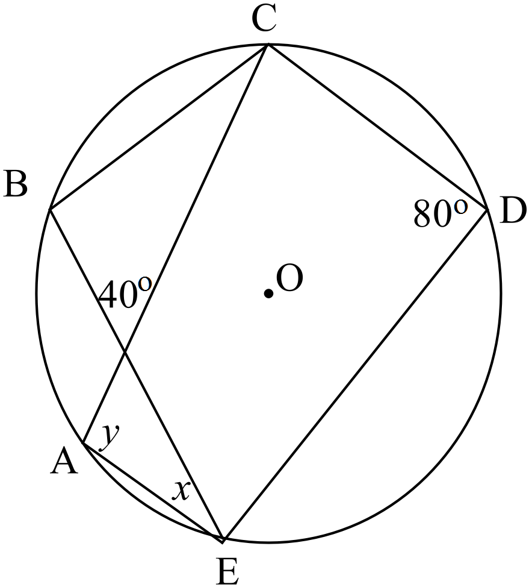

Question 9 (11 marks)

(a) (i) Use the graph of 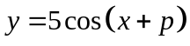to estimate the value of . (1)
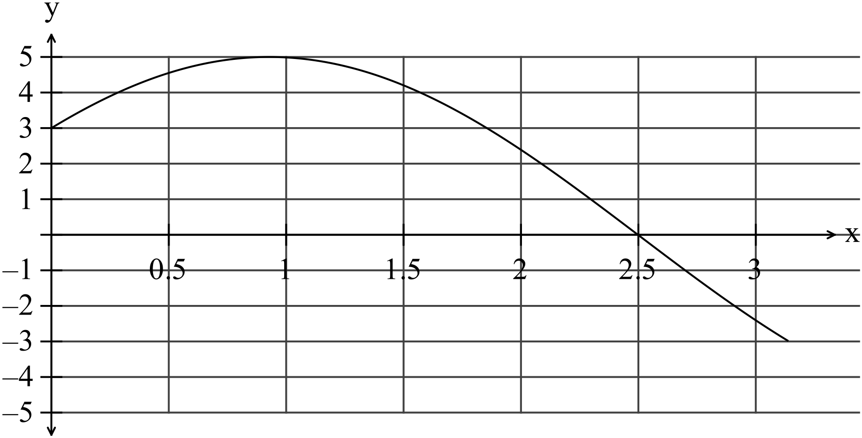

(ii) Comment on the effect on the graph of changing the value of. (1)

(iii) Determine the values of 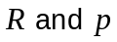 given 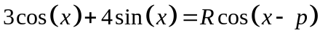
for 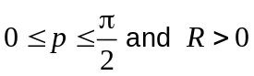. (4)

(iv) Hence solve 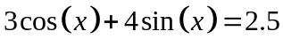 for, correct to two decimal places, on the domain 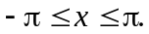 (3)

(b) Write down the equation of the function graphed below. (2)
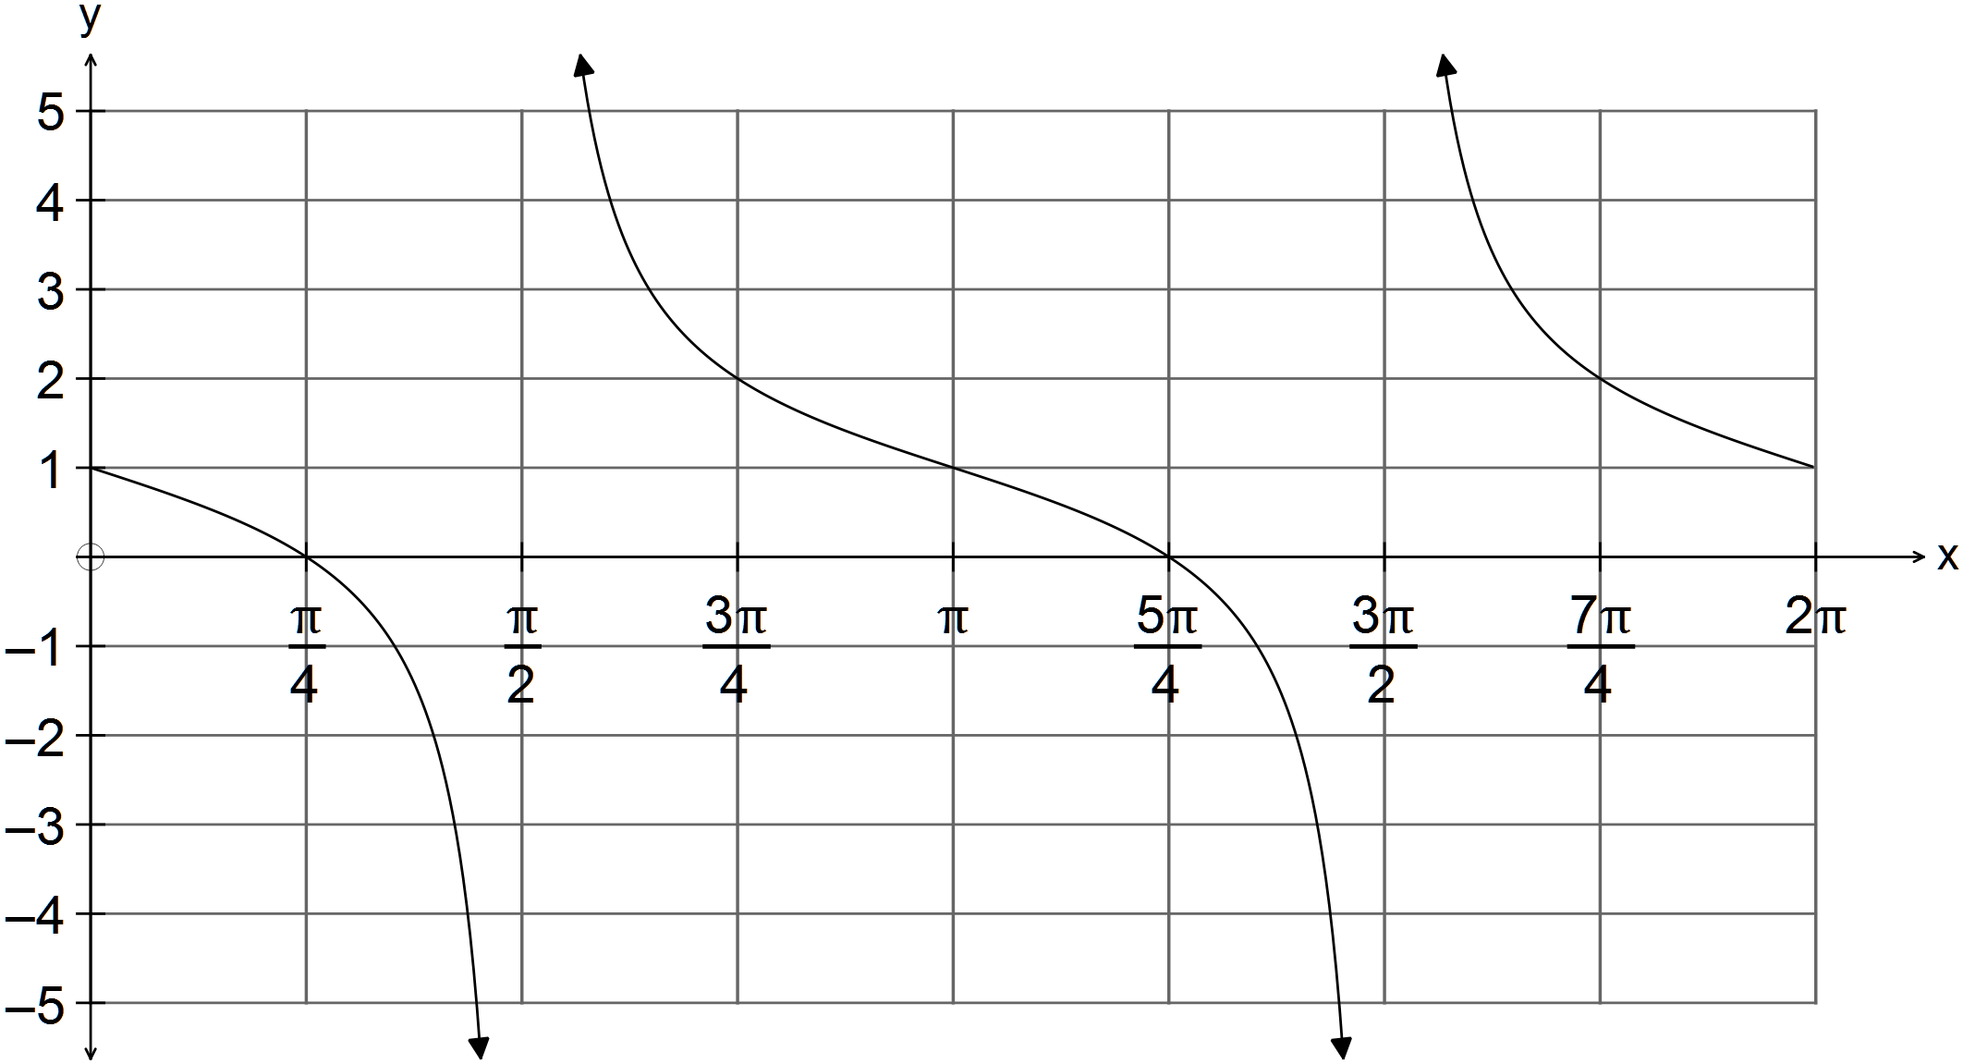

Question 10 (7 marks)
(a) Simplify 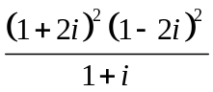 . (3)

(b) Find and if 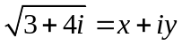 where and are real numbers (4)
HINT: Square both sides.
Question 11 (12 marks)
(a) Given the points P(5,1) and Q(2, -2),
(i) determine |PQ|. (1)

(ii) find the scalar projection of 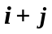 on PQ. (2)

(b) A bear in a zoo has been anaesthetised so it can be moved to have its annual health
check. They have got it onto a plastic sheet and want to drag it to the truck.
Three men exert forces as listed below. If the combined force is 300 N, they can manage the bear without having get the tractor to drag him.
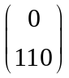
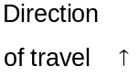
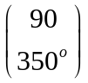
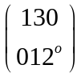

Determine the magnitude and direction of the resultant force in the direction of travel and
decide if they will have to use the tractor. (4)


(c) Use a vector proof to show that
“The sum of the squares of the lengths of the diagonals of a parallelogram is equal
to the sum of the squares of the lengths of the sides.” (5)

Question 12 (9 marks)
(a) Solve the following equation 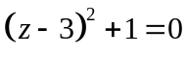. Show all working. (2)

(b) Express the complex numbers below in the form 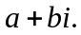
(i) 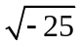 (1)

(ii) 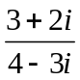 (3)

(c) The vectors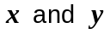are defined below.
has a magnitude of 3 and makes an angle of 60º with the positive x axis.
has a magnitude of 2 and makes an angle of 45º with the positive x axis.
Determine 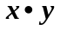. (3)

Question 13 (6 marks)
(a) Write the contrapositive of the statement “If today is Tuesday, then Donna will go to the
library.”
(1)

(b) Write the conclusion to the following deductive argument
“All cats have 4 legs.
Big Boy is a cat.” (1)

(c) Use a proof by contradiction to prove that there are infinitely many prime numbers. (4)

Question 14 (9 marks)

(a) Perth Concert Hall's auditorium has a total capacity of 1731. At the recent WASO concert,
there were 872 people in attendance.

Show that there will be at least two people in the hall who have the same first and last initial in their names. (2)

Paul has one red bin for rubbish, 2 green bins for garden waste and 2 yellow bins for recycling. Paul keeps his bins lined up on the back fence behind his garden shed.
(b) In how many ways can Paul line up his bins with identically coloured bins are adjacent? (1)


(c) How many of the numbers from 1, 2, 3, ….90 are not multiples of 6 or 7? (3)

(d) Prove that 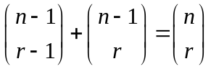 (3)
Question 15 (6 marks)

The average temperature in Perth over one year can be approximated by the function 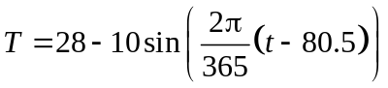 where T is degrees C and in days taken from January 1st, when . NB Assume there are 365 days in the year.

Consider the sketch on the set of axes below:
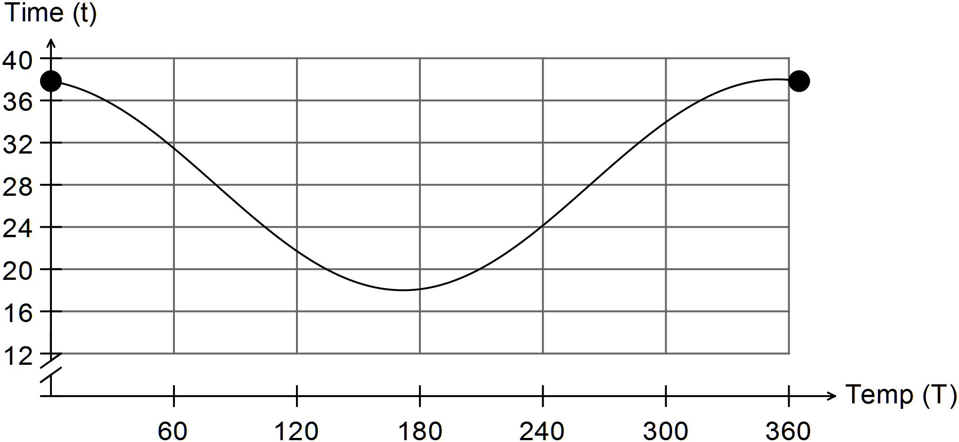
(a) Find the temperature expected on January 1st. (1)

(b) Find the date of the minimum expected temperature. (1)

(c) Between what dates is the average temperature expected to be less than 24? (2)

(d) What percentage of the year has the average temperature greater than 32? (2)

Question 16 (4 marks)
Prove 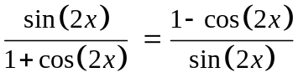 (4)

Question 17 (14 marks)
(a) ABC is a triangle. The triangle is reflected about the x axis then rotated 45º about the origin in an anti-clockwise direction to form triangle A”B”C”.

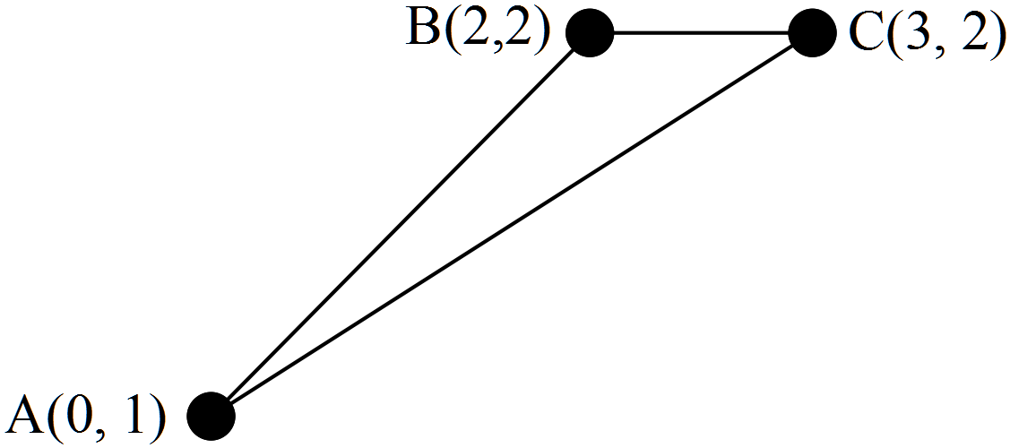

(i) Write down the matrix that transforms the coordinates A, B and C into the
coordinates A”, B” and C”. (3)

(ii) Find the area of the triangle ABC and hence determine the area of the triangle
A”B”C using the matrix. (3)

(iii) Determine the matrix that will transform triangle A”B”C” back into triangle ABC.
(2)

(b) A linear transformation given by 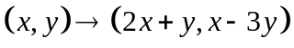 transforms quadrilateral
ABCD into the quadrilateral A’B’C’D’.
(i) Write down the corresponding transformational matrix. (2)

(ii) Determine how much bigger in area quadrilateral A’B’C’D’ is than quadrilateral
ABCD. (2)

(c) A linear transformation using the matrix 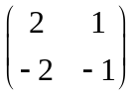 transforms quadrilateral
ABCD into the quadrilateral A’B’C’D’.
(i) Explain why a matrix to transform quadrilateral A’B’C’D’ back to quadrilateral
ABCD cannot be found. (1)

(ii) Explain with reference to the transformed shape. (1)

Question 18 (8 marks)
(a) Given the set of different numbers in the diagram below
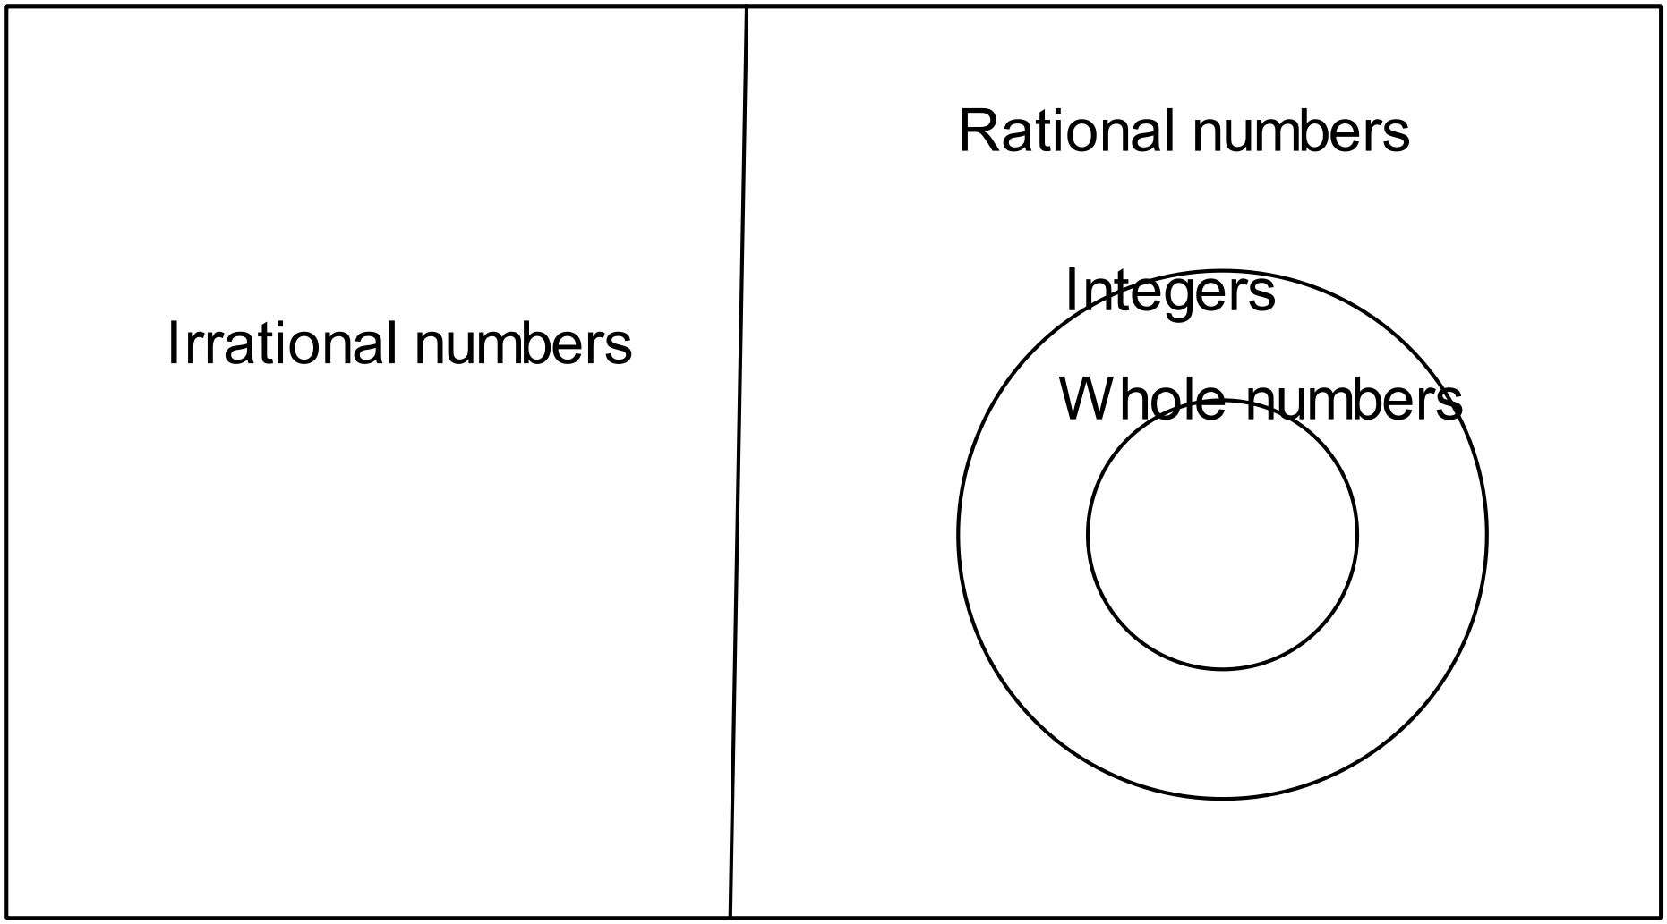
(i) place each of the numbers 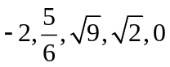in the appropriate place on the diagram. (2)

(ii) Give an example of a number that does not fit into this diagram. (1)

(b) Prove using mathematical induction that 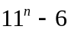 is divisible by 5. (5)

Question 19 (7 marks)

Two transformations are defined as
 is a transformation using the matrix 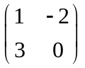and
 is a rotation of 270º anti- clockwise about the origin.

(a) Find the transformational matrix followed by. (4)

(b) (i) Determine the image of 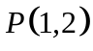under M followed by R. (2)

(ii) Find the matrix that takes the image 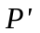back to . (1)

END OF SECTION TWO

